**Student Name : Uzma Ejaz**

**Problem Statement:**

**Upwork is a leading online platform that has transformed the way businesses and freelancers collaboratein the digital age. It serves as a dynamic marketplace connecting Data Analytics and Business Intelligenceskilled professionals with clients seeking talent for various projects. On Upwork, freelancers offer a widerange of services like Data Cleaning, Data Analytics, Data Visualization and Business Intelligence. The platform has become an essential hub for both freelancers looking to build their careers and clients aimingto complete projects efficiently and effectively.**

**Tasks:  
1) Visit Upwork website. Go to the top right corner to locate the search bar. Enter keyword “Data  
Analytics” in the search bar and choose 'Talents', 'Projects’, ‘Jobs' from dropdown (besides the  
search bar) one by one. (Provide 3 screenshots).**

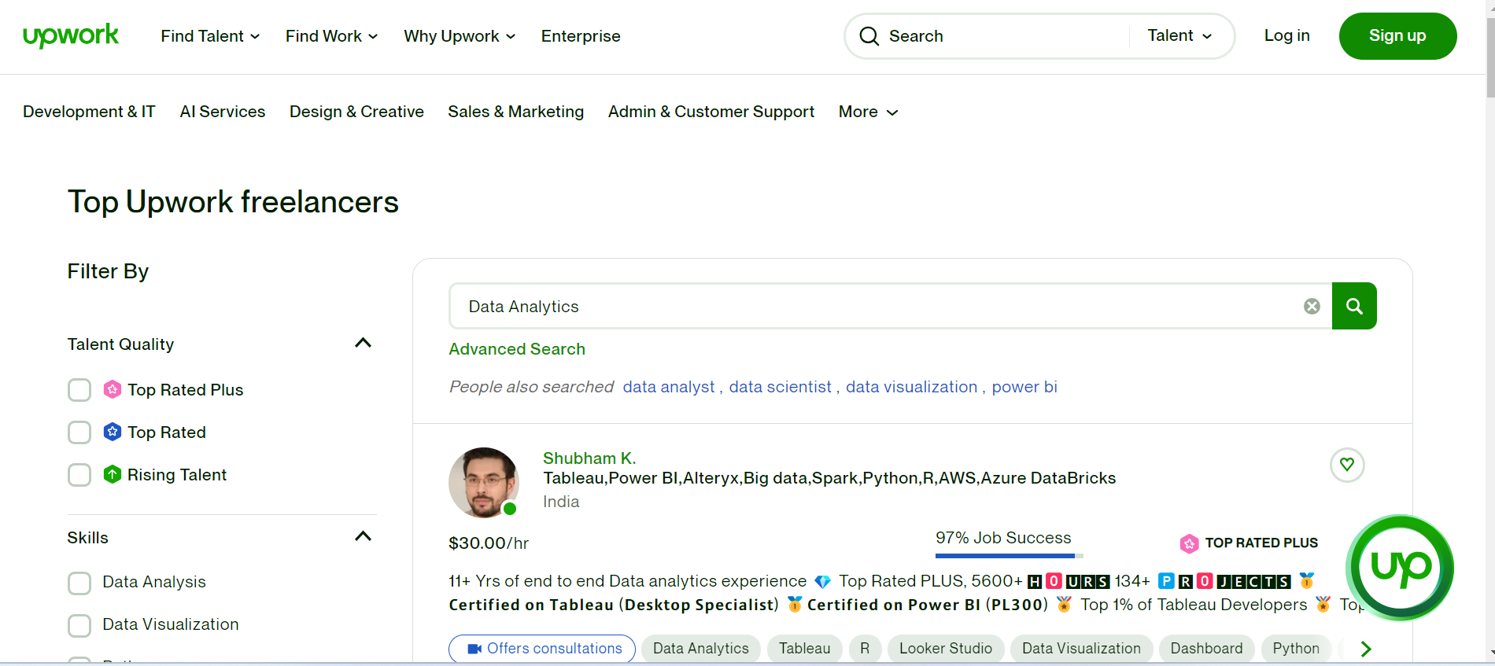

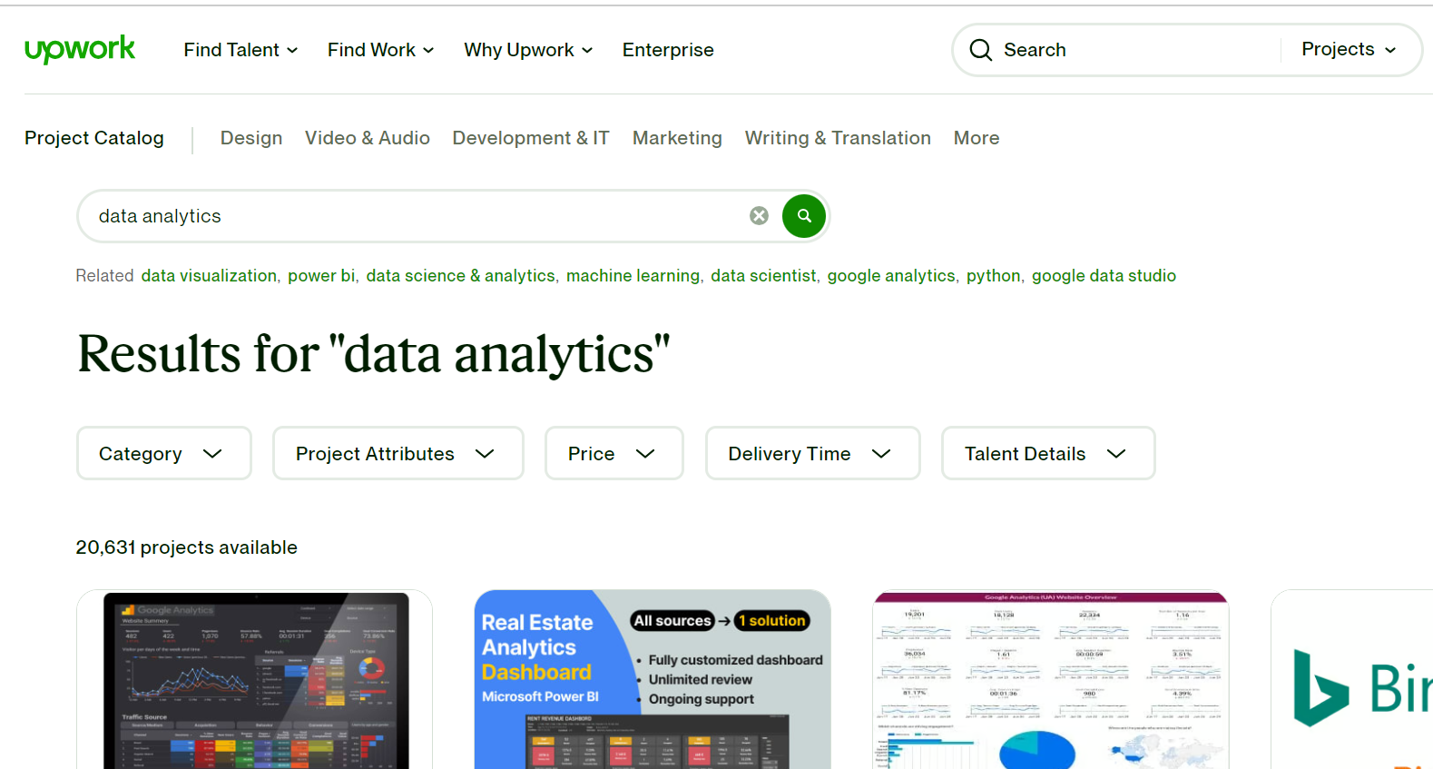

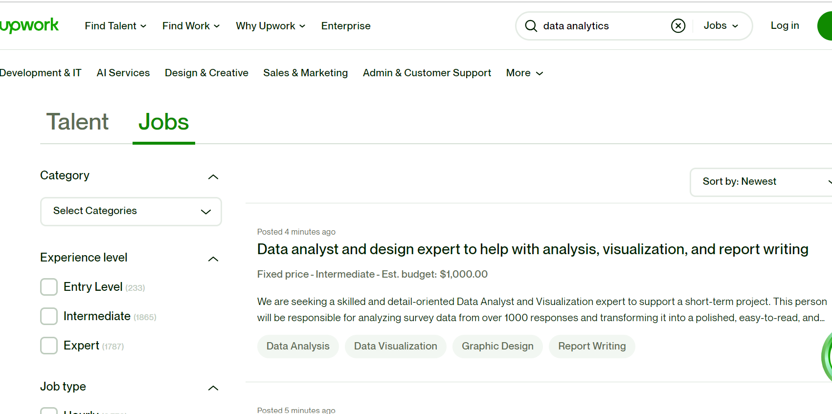

**2) Search for an appropriate job using relevant keywords and pick the one that aligns with your Data Analytics skills/expertise. (Provide Screenshot):**

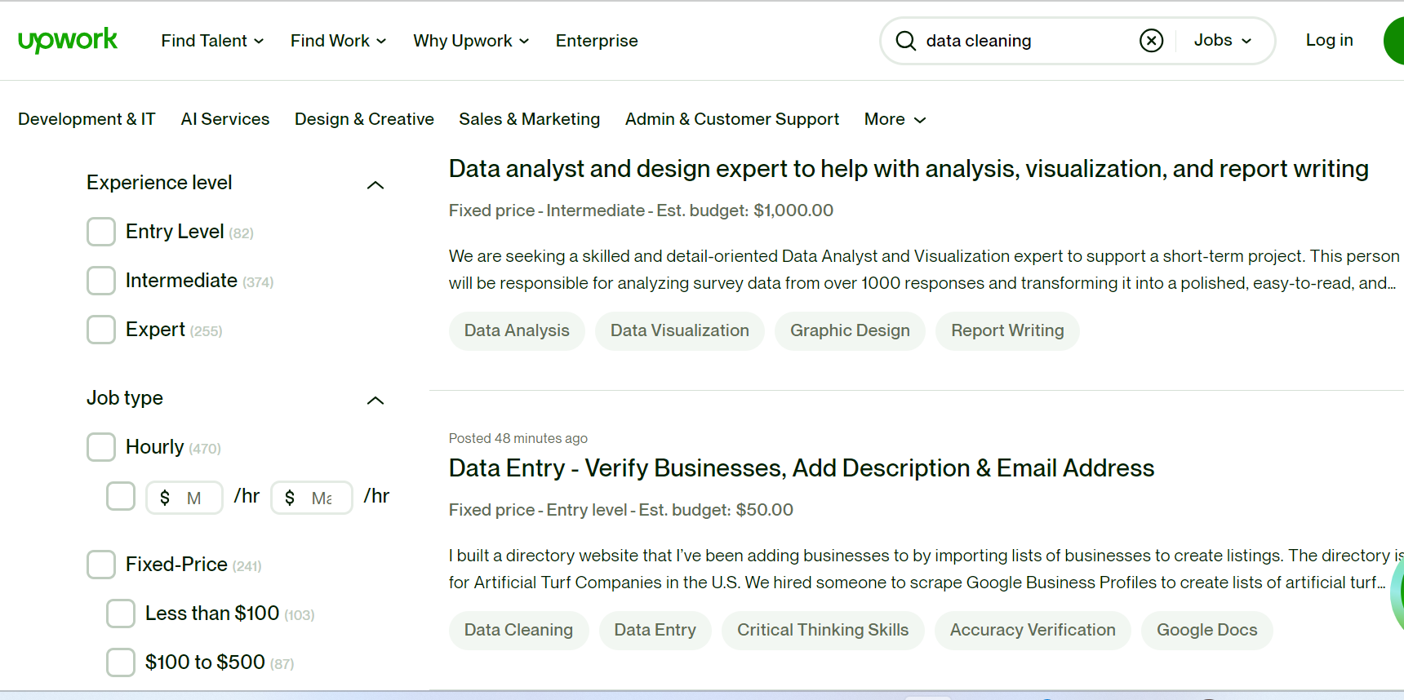

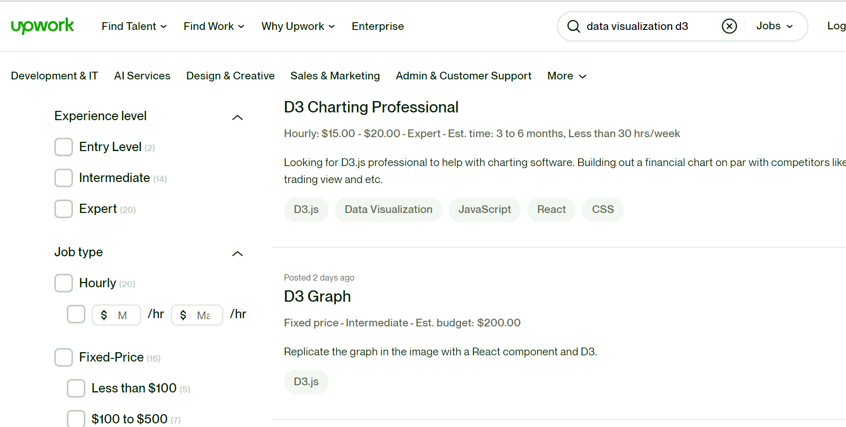

**3) Mention at least 3 reasons for selecting the project.**

1. **Enhancing Decision-Making Processes: Projects involving data analytics and business intelligence are frequently started in order to improve an organization's decision-making procedures. The goal of these initiatives is to offer knowledge and useful data that will aid in making well-informed, data-driven decisions.**
2. **Performance Optimization: Projects using data analytics and business intelligence can assist in locating opportunities for performance optimization. Organizations can find patterns, trends, and correlations with big data analysis that would not be seen by manual analysis.**
3. **Competitive edge: Acquiring a competitive edge is essential in the data-driven corporate environment of today. Businesses may use data to obtain insights into consumer behavior, market trends, and rivals' tactics by choosing a data analytics and business intelligence project.**

**4) Write down the name of tools related to Data Analytics and business intelligence that you will use for completing the chosen project.**

1. **Tableau: Tableau is a popular business intelligence and data visualization application. With it, users may combine data from several sources to create interactive reports, dashboards, and visualizations. Tableau is a potent tool for gathering insights and efficiently disseminating discoveries since it facilitates intuitive data exploration and analysis.**
2. **Power BI :Microsoft's business analytics application Power BI offers interactive visualizations and business intelligence features. It enables users to share dashboards and reports, link to several data sources, and produce sophisticated visualizations. Because of its intuitive interface and frequent integration with other Microsoft products, Power BI is a well-liked option for data reporting and analytics.**
3. **Python: Used extensively in machine learning and data analytics, Python is a flexible programming language. It provides a range of libraries.**
4. **R: R is a computer language created especially for statistical computation and data analysis. It provides a large selection of tools and packages that make advanced statistical modeling, data processing, and visualization easier. Because of its broad statistical capabilities, R is especially well-liked in academic circles and among statisticians and data scientists.**
5. **SQL, or Structured Query Language, is a common language used to administer and work with relational databases. It is often used for database queries to retrieve and analyze data, as well as for data extraction, transformation, and loading (ETL) procedures. Working with structured data in a data analytics or business intelligence project requires the use of SQL.**